Messenger Budget

* Deployment Precondition
* Assume total users from 100,000 to 3,000, 000
* Assume we **don’t keep history data** in server
* Assume each user 0.5KB for each day, 0.5 * 30 = 15kB for each month **(type 256 words each day**)
* Assume each XMPP server **keeps 200, 000 user sessions**
* Traffic Prediction

1. One-on-One Chat

15KB * 100, 000 * 2 (flow in, flow out) = 3G

15KB * 3,000,000 * 2(flow in, flow out) = 90G

2. Group chat, assume group average 5

1.5g * 5 = 7.5G

45g * 5 = 225g

Then ideal range for 100,000 ~ 3,000, 000

8G ~ 250G traffic prediction

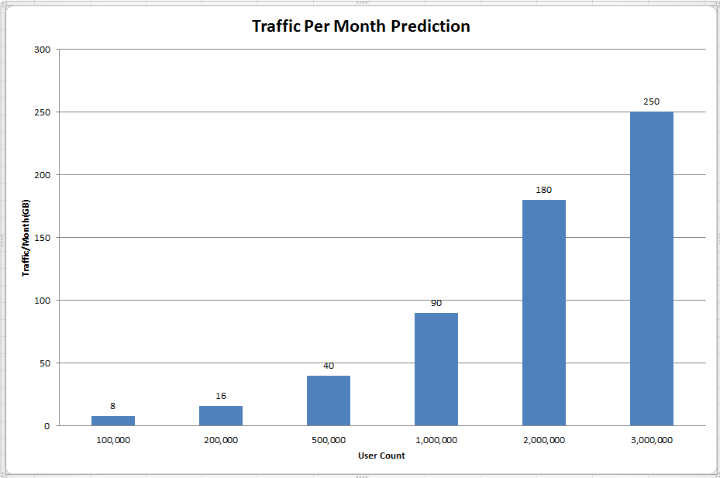

* Cost Prediction

1. CDN calculator

http://www.cdncalc.com/

Akamai cost = $100 for each month

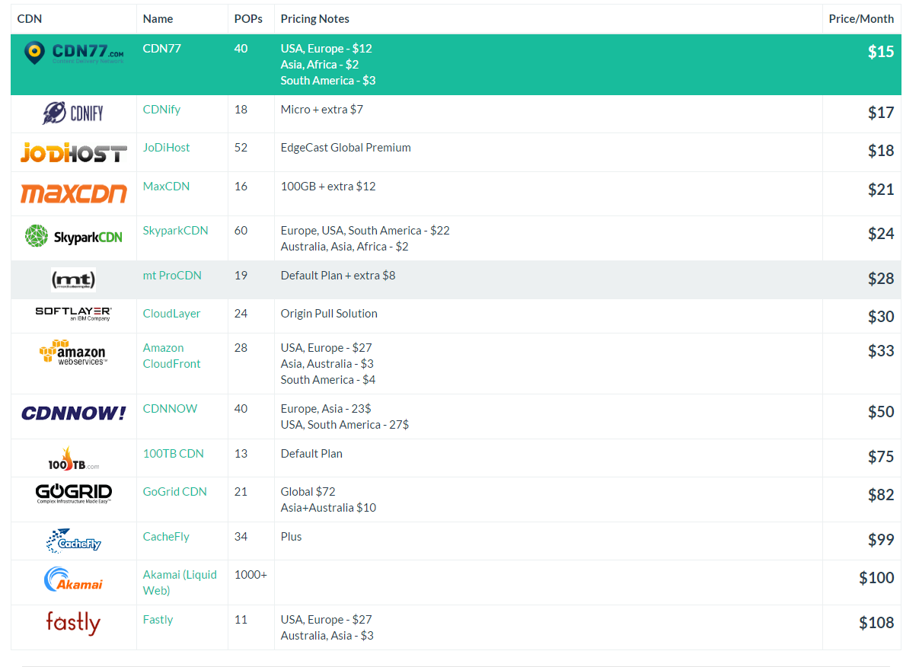

1. AWS + Akamai CDN

https://calculator.s3.amazonaws.com/index.html#r=IAD&s=EC2&key=calc-AB9E8C81-BE06-4605-B16A-853C1289D091